## Problem

The TYPO3 system is regularly updated, introducing new functionalities and improving security. Due to frequent updates, this also presents a challenge for website developers to ensure their sites remain compatible and functional after changes. The costs of upgrading websites built on TYPO3 CMS range from tens to hundreds of thousands, and include:

* Technical audit and migration plan
* TYPO3 core upgrade (e.g., from v9 to v12)
* Extension migration and refactoring (the most costly process)
* Frontend updates
* Testing
* Documentation, potential training in project management

## Statistics

#### Slow Migration

* Many websites remain on older versions (v9, v10) long after official support has ended

#### Technical Problem

* Approximately 40-50% of TYPO3 websites operate on versions without active support, creating security risks for personal data and causing technical limitations or development problems

#### Causes of Delayed Updates:

* Migration costs for large, complex websites
* Dependency on third-party extensions incompatible with newer versions
* Lack of internal technical resources to carry out migration

## Solution

The TYPO3 update tool was created to simplify and automate the update process, allowing clients to save money through the use of a free personalized tool that offers easy-to-understand steps. This is achieved through:

* Analysis of the existing site on the given TYPO3 installation
* Identification of compatibility for extension versions
* Generation of update commands, serving this through a simple process that offers a step-by-step tutorial
* Providing steps for safe migration

## Project Architecture

The project consists of:

* React + Vite as the frontend framework
* Direct calls to external APIs (TYPO3, Packagist) using axios
* JavaScript libraries for analysis and command generation
* A .json file with fetched TYPO3 version data instead of a database

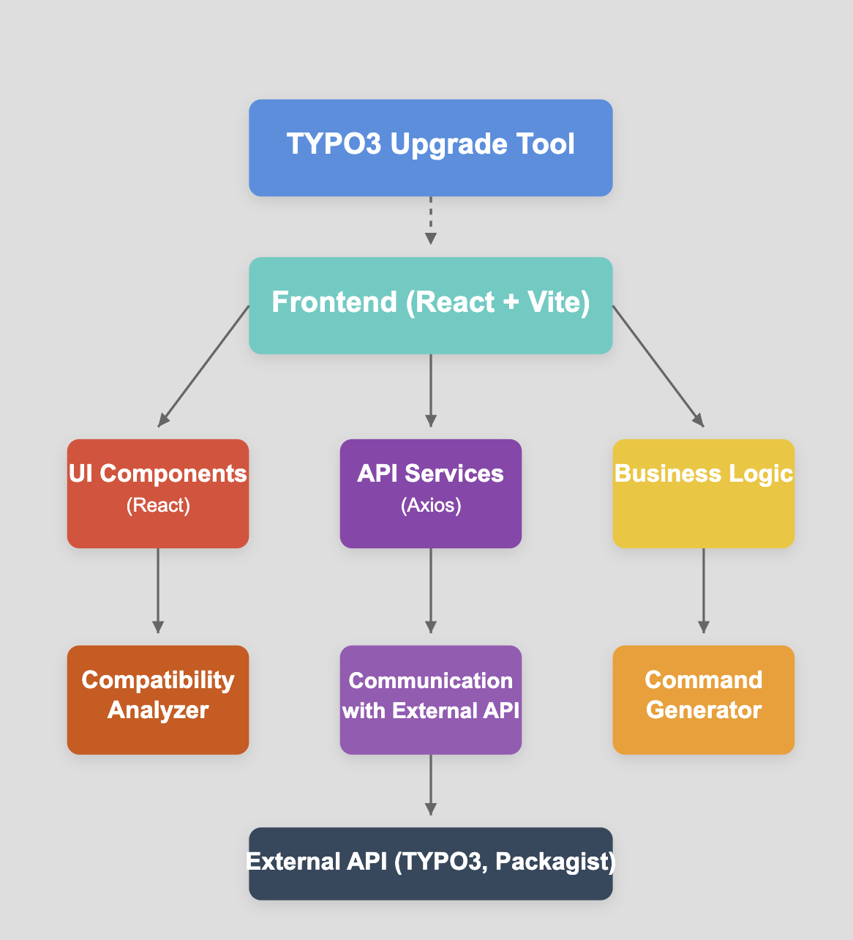

## Features

* Visually appealing list of Typo3 versions from Typo3 documentation with their release, support date, database and php information
* Upgrade Path which provides the support for clients with Typo3 upgrading problems. A step-by-step tour that lets client personalize their path by uploading Typo3 Project using .zip file into Site Analyzer. The steps may be extracted into PDF file. Possible choices for tutorial are:
  + Console Upgrade with step-by-step or list upgrade path
  + Admin Panel Upgrade with step-by-step or list upgrade path
* Site Analyzer upload input That detects extensions installed locally and provides upgrade path link with those extensions included in command prompts fetching information from packagist. Also Identifies if the extensions are compatible with target version.
* Site Analyzer manual input which lets client customize their project analysis
* Possible choice of selecting Composer or Non-composer project installation upgrade path

## Potential Development

* Database with common problems and solutions (FAQ)
* A fully functional TYPO3 plugin that collects client project data and is compatible with several versions using Interfaces (the current one has issues with this)
* The developed tool could be integrated with the TYPO3 ecosystem. TYPO3 could independently offer an update service or only collect leads and information for its partners, using processed and customized data about the client and their installation specifications
* A "Need Support" button where the client enters their data, and TYPO3 provides the client with a reflink that sends the client to a partner
* Configuration for different environments (MacOS, Windows, Linux)
* Backend and database implementation to optimize applications
* Integration with composer patches; automatic application of fixes for incompatible extensions, patch management in the update process
* Console or admin panel upgrade option. Customized tutorial for this

## Proof of Concept

* [Drupal Upgrade Status](https://www.drupal.org/project/upgrade_status) (A Drupal module showing which modules are ready for migration and what needs to be fixed. Overview of deprecated code, automatic compatibility scans)
* [PHP Compatibility Checker](https://github.com/PHPCompatibility/PHPCompatibility) (CLI tools for scanning PHP code for incompatibilities between versions. They are used by TYPO3 developers but lack GUI and integration with TYPO3-specific API)
* [Symfony Insight](https://insight.symfony.com/) (Analysis of Symfony projects, including compatibility with current framework versions)

## Repository

* <https://github.com/Felipi2021/Typo3_Upgrade_Tool>